# 2

**Template**

**Brainstorm**

## Write down any ideas that come to mind that address your problem statement.

### 10 minutes

**3**

# Group ideas

## Take turns sharing your ideas while clustering similar or related notes as you go. In the last 10 minutes, give each cluster a sentence-like label. If a cluster is bigger than six sticky notes, try and see if you and break it up into smaller sub-groups.

**TIP**

You can select a sticky note and hit the pencil [switch to sketch] icon to start drawing!

### 20 minutes

**4**

# Prioritize

## Your team should all be on the same page about what's important moving forward. Place your ideas on this grid to determine which ideas are important and which are feasible.

### 20 minutes

#### v.muthulakshmi

**s.preethy**

**TIP**

Add customizable tags to sticky notes to make it easier to find, browse, organize, and categorize important ideas as themes within your mural.

Get help from family members or friends

###### calendar alerts

link yours medication dose with a daily activities

###### Record each dosage

**set an alarm**

###### Care service from pharmacy

**using organized pill box in week type**

###### Use pill box.

using sticky notes in visible area like kitchen , bedroom.

Write a medicine name and time in paper and paste it.

Link your medication dose with daily activities.

Moniter our regular activity and keep it with us.

###### Getting help from caretaker (nurse).

Get help from family member or friends.

###### use pill box

write a medicine name and time inpaper and paste it

Make taking your medicine a habit

**Supervise closely**

**Use medicine remainder app.**

**Avoid the un-nessary health issue.**

Entering the medicine name.

**Creating an app.**

**Compulsory take medicine at time.**

**Control the memory loss**

**m.sabina**

**j.srisneha**

#### v.geetha

###### avoid excess medicine

**mobile medication remainder appp**

###### pill remainder are used

**using organized pill box in week type**

using sticky notes in visible area like kitchen

getting help from care taker(nurse)

keep an up to data list of your medication name

###### post a note in mobile

carry extra doses,record each dose

Monitor our regular activity and keep with us

create a routine,keep it visible

###### flip pill bottle over

**take medicine at same time**

Getting call from hospital medical(pill) history

**keep it visible place**

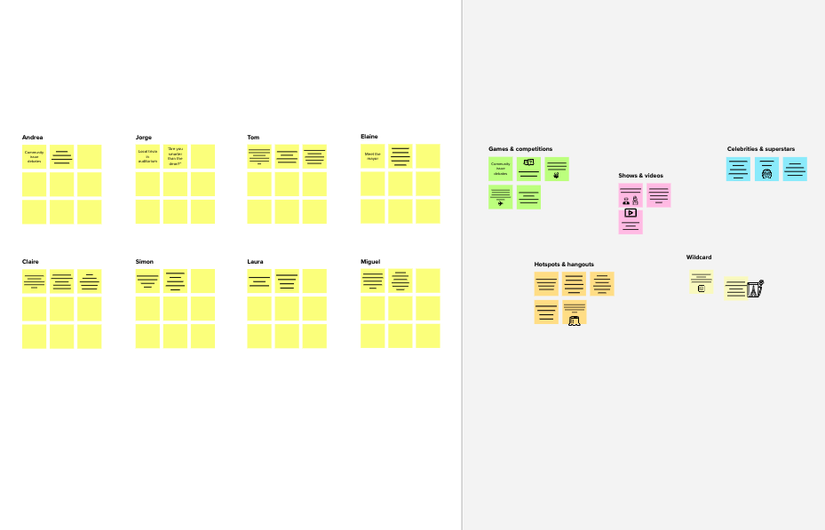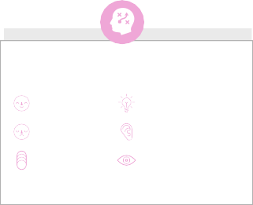

**1**

**Define your problem statement**

What problem are you trying to solve? Frame your problem as a How Might We statement. This will be the focus of your brainstorm.

**5 minutes**

**Key rules of brainstorming**

To run an smooth and productive session

Stay in topic.

Encourage wild ideas.

Defer judgment.

Listen to others.

Go for volume.

If possible, be visual.

**Need some inspiration?**

See a finished version of this template to kickstart your work.

[**Open example**](https://app.mural.co/template/e5a93b7b-49f2-48c9-afd7-a635d860eba6/93f1b98d-b2d2-4695-8e85-7e9c0d2fd9b9)

[**Share template feedback**](https://muralco.typeform.com/to/CiqaHVat?typeform-source=app.mural.co)

**10 minutes** to prepare

**1 hour** to collaborate

**2-8 people** recommended

**Brainstorm**

**& idea prioritization**

Use this template in your own brainstorming sessions so your team can unleash their imagination and start shaping concepts even if you're not sitting in the same room.

**C Learn how to use the facilitation tools**

Use the Facilitation Superpowers to run a happy and productive session.

[**Open article**](https://support.mural.co/en/articles/2113740-facilitation-superpowers)

**B Set the goal**

Think about the problem you'll be focusing on solving in the brainstorming session.

**A Team gathering**

Define who should participate in the session and send an invite. Share relevant information or pre-work ahead.

**Before you collaborate**

A little bit of preparation goes a long way with this session. Here’s what you need to do to get going.

**10 minutes**

**PROBLEM**

**Elder peoples forget to intake the medicine at right time .It can be solved by Medicine Remainder App.**



# Importance

If each of these tasks could get done without any difficulty or cost, which would have the most positive impact?

**TIP**

Participants can use their cursors to point at where sticky notes should go on the grid. The facilitator can confirm the spot by using the laser pointer holding the **H key** on the keyboard.

# Feasibility

##### Regardless of their importance, which tasks are more feasible than others? (Cost, time, effort, complexity, etc.)

|  |  |  |  |  |
| --- | --- | --- | --- | --- |
|  |  |  |  |  |
|  |  |  |  |  |